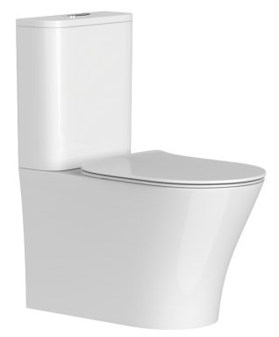

Anti-bacterial glazing
Super hydrophilic
Anti-stain technology
Easier cleaning
Rimless technology

- Code: AB2232+AS8232D
- Warranty: 25 Years warranty on ceramic
1 Years warranty on the toilet seat
3 Years warranty on the cisterns valves， plastic and internal parts

Specifications
AB2232H+AS8232D
Close Coupled Back to Wall Toilet Suite
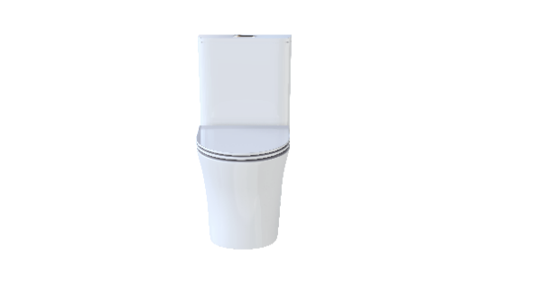
Soft close, quick release seat
WELS 4 star, 4.5/3 ltrs/min
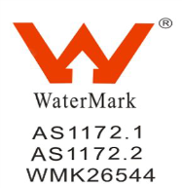
Size: 654X398X810MM
Bottom and back inlet available
• S-Trap Installation: set out: 70-140mm
• P-Trap installation: set out: 185mm

Model AB2232H+AS8232D Standard Installation
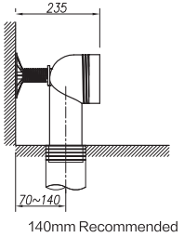
Toilet outlet
