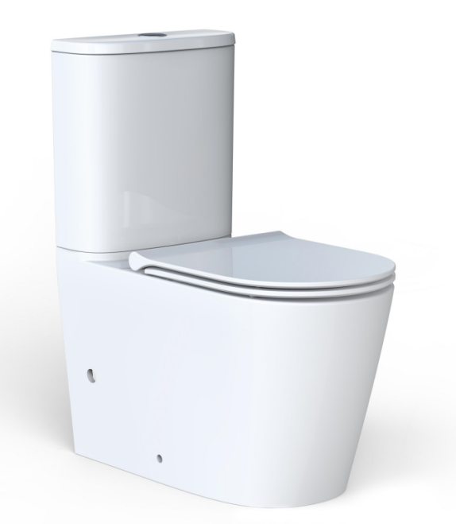
Specifications
AB2231H+AS8231D
Close Coupled Back to Wall Toilet Suites

DESCRIPTION
• Rimless, hygienic flush pan
• UF quick release, soft close seat
• High quality, R&T flush mechanism
• Water inlet: top left or bottom right inlet;
• Included components:
Toilet tank 4.5/3L
Toilet Pan, P Trap
UF cover&seat
Vario pan connector for Strap
Fill valve


• S-Trap Installation: set out: 70-140mm
• P-Trap installation: set out: 180mm

Standard Installation
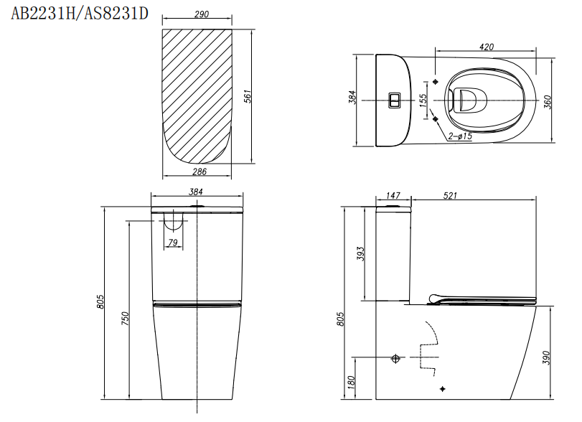
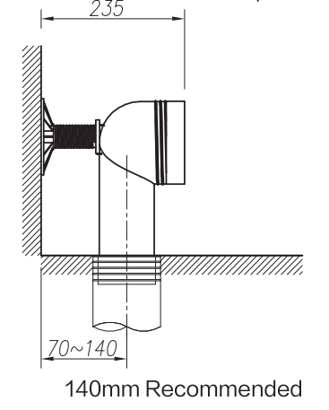
Toilet outlet

